LINUX INTERNALS IPC ASSIGNMENT
Vandit.Prajapati (150187)

Q-1) Write a program that creates a shared memory region and displays shared memory id and also print address at which shared area in this process starts from.

#include<stdio.h>
#include<sys/ipc.h>
#include<sys/types.h>
#include<sys/shm.h>

int main()
{
int id;
char *addr;

id=shmget(48, 250, IPC_CREAT|0644);

printf("Shared Memory ID: %d\n",id);
addr=shmat(id,0,0);
printf("The address of shared area is: %p\n",addr);
return 0;
}

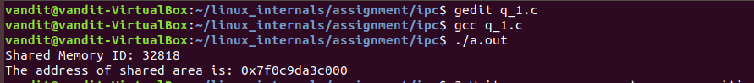

Q-2) Write a program that uses msgctl() and prints number of messages,number of bytes in message queue and also get Maximum number of bytes in queue for already existing message queue
and also remove message queue at the end.

#include<stdio.h>
#include<stdlib.h>
#include<unistd.h>
#include<sys/types.h>
#include<sys/ipc.h>
#include<sys/msg.h>

struct msgbuf
{
long mtype;
char data[512];
};

int main(int argc, char *argv[])
{
int qid;
struct msqid_ds buf;

struct msgbuf m;

qid=msgget(32, IPC_CREAT|0644);
printf("Mesaage Queue ID: %d\n", qid);

m.mtype=atoi(argv[1]);
strcpy(m.data, argv[2]);
msgsnd(qid, &m, strlen(m.data)+1, 0);

msgctl(qid, IPC_STAT, NULL);
printf("No. of messages: %hi\n", buf.msg_qnum);
printf("No. of bytes in message queue: %hi\n", buf.msg_cbytes);
printf("Max no. of bytes in message queue: %hi\n", buf.msg_qbytes);

msgctl(qid, IPC_RMID, NULL);
}
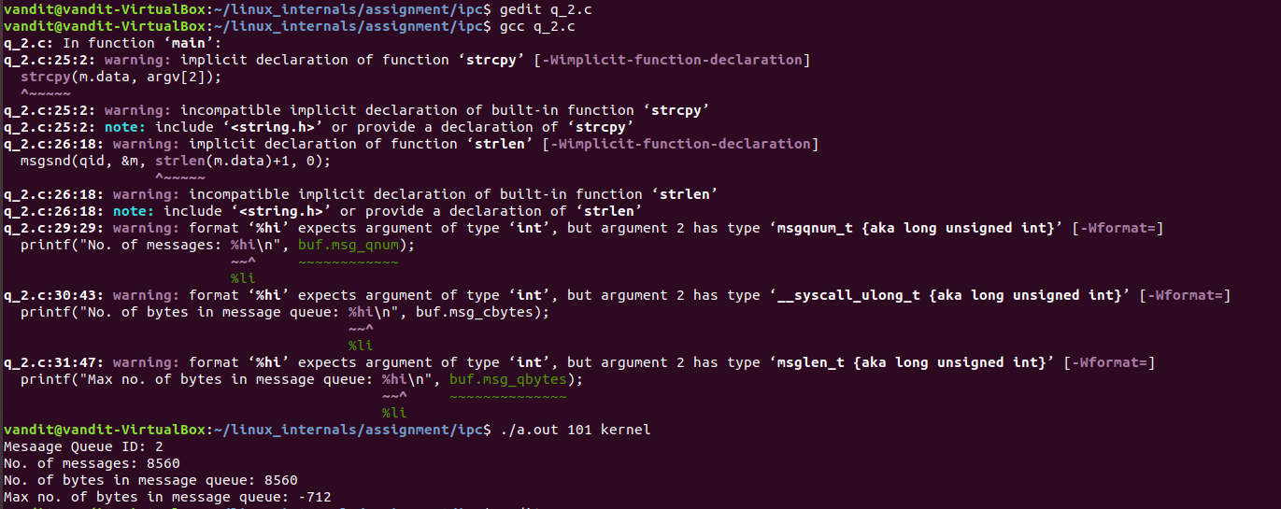

Q-3) Write a program parent process writing to pipe and child reading toggled data from pipe, and also analyse the data flow order from write end to read end.

#include<stdio.h>
#include<unistd.h>
#include<stdlib.h>

int fds[2];

void parent_code()
{
char *buf1="Vandit";
char *buf2="Prajapati";
close(fds[0]);
write(fds[1],buf1,6);
write(fds[1],buf2,9);
printf("End of Parent\n");
sleep(2);
}

void child_code()
{
char buf[100];
int n,i;
close(fds[1]);
n=read(fds[0],buf,100);
printf("No of chars read = %d\n",n);
for(i=0;i<n;i++)
{
printf("%c",buf[i]);
}
printf("\nEnd of child\n");
sleep(2);
}

int main()
{
int res,i;
pid_t p;

res=pipe(fds);

if(res==-1)
{
perror("pipe");
exit(1);
}
p=fork();
if(p==0)
{
child_code();
}
else
{
parent_code();
}
return 0;
}
